

FUNDAMENTALS OF
WEB DESIGN
(415)

STATE 2024

Multiple Choice (25 @ 2 points each) __________ (50 points)
Application __________ (250 points)
TOTAL POINTS __________ (300 points)

Test Time: 90 minutes

GENERAL GUIDELINES:
Failure to adhere to any of the following rules will result in disqualification:
- Member must hand in this test booklet and all printouts if any. Failure to do so will result in disqualification.
- No equipment, supplies, or materials other than those specified for this event are allowed in the testing area. No previous BPA tests and/or sample tests (handwritten, photocopied, or keyed) are allowed in the testing area.
- Electronic devices will be monitored according to ACT standards.

MULTIPLE CHOICE ANSWERS
1. A
2. C
3. C
4. B
5. B
6. A
7. B
8. A
9. A
10. A
11. C
12. A
13. A
14. A
15. B
16. B
17. C
18. A
19. B
20. A
21. D
22. B
23. B
24. A
25. A

APPLICATION

Overview
You are tasked with creating a modern, responsive web page titled "Explore Chicago." This page should showcase various attractions, historical sites, and fun facts about Chicago, using advanced HTML5 and CSS3 techniques to create a visually appealing, accessible, and informative experience.

Design Requirements
- Modern Layout:
- Employ Flexbox for layout design in various sections.
- Include a header, main, and footer.

- Navigation Bar:
- Located in the header.
- Create jump links for the following: Attractions, History, Fun Facts, Contact

- Showcase Area:
- A banner section with a background image (“images/chicago-banner.jpg”).
- Heading: "Welcome to Chicago" and subheading: "Explore the city of winds".

- Content Sections:
- Located in the main.
- Three sections in main: Attractions, History, Fun Facts
- Attractions
  - Title
    - Discover the Wonders of Chicago
  - Text Content
    - Willis Tower: An iconic skyscraper offering stunning skyline views. A must-visit for breathtaking sights.
    - The Art Institute of Chicago: Home to an impressive collection of artworks, spanning thousands of years.
    - Navy Pier: A vibrant location filled with amusement rides, shops, and eateries, perfect for family fun.
  - Image
    - chicago-attractions.jpg
  - Table Content
    - Landmark, Opening Hours, Ticket Price
    - Willis Tower, 9 AM - 10 PM, $25
    - The Art Institute of Chicago, 10 AM - 5 PM, $20
    - Navy Pier, 10 AM - 8 PM, Free Entry
- History
  - Title
    - A Journey Through Time in Chicago
  - Text Content
    - From its founding in 1833 to becoming a bustling metropolis, Chicago's history is as rich as it is diverse.
    - Great Chicago Fire (1871): A major event that led to the extensive rebuilding of the city.
    - World's Columbian Exposition (1893): A landmark world fair that showcased Chicago's resurgence.
  - Image
    - chicago-history.jpg
- Fun Facts
  - Title
    - Fun Facts About Chicago
  - Text Content
    - Chicago's nickname "The Windy City" was coined not just for its weather, but also for its long-winded politicians.
    - The first Ferris wheel made its debut in Chicago in 1893.
    - Chicago River is the only river in the world that flows backward, a result of an engineering marvel.
  - Image
    - chicago-funfacts.jpg

- Styling:
- External stylesheet.
- Consistent color scheme and typography.

- Images:
- All images must have alt text with a basic photo description.
- Images should be stored and called from the images folder.

- Footer:
- Contact information
  - Contact Information: Chicago Tourism Office, 123 City St, Chicago, IL, 60601, (312) 555-1234, info@chicagotourism.com

- Accessibility and Responsive Design:
- Ensure website accessibility (text alternatives for images, keyboard navigability).
- Use media queries for responsiveness on different devices.

Criteria | Description | Points Possible | Points Earned
Layout and Structure | Modern layout using Flexbox, correct implementation of header, main, footer. | 40
Responsiveness | Effective use of media queries, consistent design on various screen sizes. | 30
Navigation Bar | Correct placement and linking, CSS transitions for hover effects. | 20
Showcase Area | Inclusion and styling of banner with image and text, creativity, and visual appeal. | 30
Content Sections | Accurate replication of provided content, styling, and layout of sections. | 50
Styling | Use of modern design elements, consistency in color scheme and typography. | 30
Images and Tables | Correct implementation and alt text for images, effective use of a table in Attractions section with specific landmarks, hours, and pricing. | 25
Footer | Inclusion of contact information. | 15
Accessibility | Adherence to accessibility standards. | 20
 | Total | 250

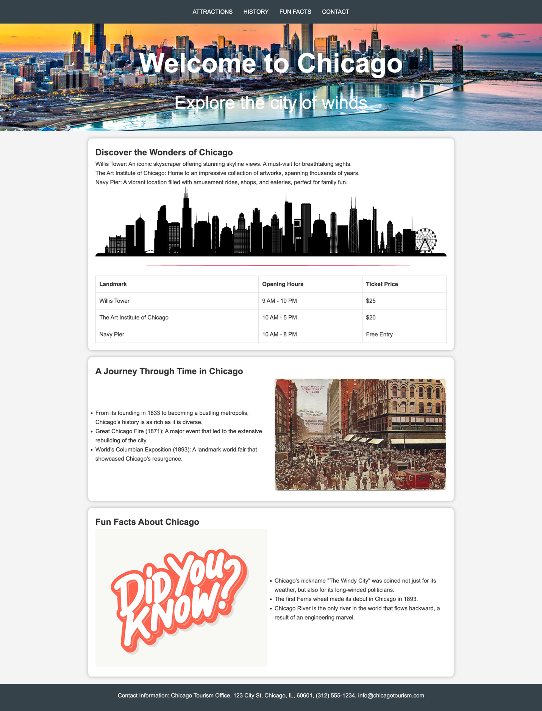

SAMPLE SOURCE CODE: COMPETITOR CODE WILL VARY
index.html
<!DOCTYPE html>
<html lang="en">
<head>
<meta charset="UTF-8">
<meta name="viewport" content="width=device-width, initial-scale=1.0">
<title>Explore Chicago</title>
<link rel="stylesheet" href="style.css">
</head>
<body>
<header>
<nav>
<a href="#attractions">Attractions</a>
<a href="#history">History</a>
<a href="#fun-facts">Fun Facts</a>
<a href="#contact">Contact</a>
</nav>
</header>
<div class="showcase">
<h1>Welcome to Chicago</h1>
<p>Explore the city of winds</p>
</div>
<div class="container">
<main>
<section id="attractions">
<h2>Discover the Wonders of Chicago</h2>
<p>Willis Tower: An iconic skyscraper offering stunning skyline views. A must-visit for breathtaking sights.</p>
<p>The Art Institute of Chicago: Home to an impressive collection of artworks, spanning thousands of years.</p>
<p>Navy Pier: A vibrant location filled with amusement rides, shops, and eateries, perfect for family fun.</p>
<img src="images/chicago-attractions.jpg" alt="Photo of Chicago Skyline">
<table>
<tr>
<th>Landmark</th>
<th>Opening Hours</th>
<th>Ticket Price</th>
</tr>
<tr>
<td>Willis Tower</td>
<td>9 AM - 10 PM</td>
<td>$25</td>
</tr>
<tr>
<td>The Art Institute of Chicago</td>
<td>10 AM - 5 PM</td>
<td>$20</td>
</tr>
<tr>
<td>Navy Pier</td>
<td>10 AM - 8 PM</td>
<td>Free Entry</td>
</tr>
</table>
</section>
<section id="history">
<h2>A Journey Through Time in Chicago</h2>
<div class="history-content">
<div class="history-text">
<ul>
<li>From its founding in 1833 to becoming a bustling metropolis, Chicago's history is as rich as it is diverse.</li>
<li>Great Chicago Fire (1871): A major event that led to the extensive rebuilding of the city.</li>
<li>World's Columbian Exposition (1893): A landmark world fair that showcased Chicago's resurgence.</li>
</ul>
</div>
<div class="history-image">
<img src="images/chicago-history.jpg" alt="Historical photo of Chicago">
</div>
</div>
</section>
<section id="fun-facts">
<h2>Fun Facts About Chicago</h2>
<div class="funfacts-content">
<div class="funfacts-image">
<img src="images/chicago-funfacts.jpg" alt="Fun fact related image of Chicago">
</div>
<div class="funfacts-text">
<ul>
<li>Chicago's nickname "The Windy City" was coined not just for its weather, but also for its long-winded politicians.</li>
<li>The first Ferris wheel made its debut in Chicago in 1893.</li>
<li>Chicago River is the only river in the world that flows backward, a result of an engineering marvel.</li>
</ul>
</div>
</div>
</section>
</main>
</div>
<footer id="contact">
<p>Contact Information: Chicago Tourism Office, 123 City St, Chicago, IL, 60601, (312) 555-1234, info@chicagotourism.com</p>
</footer>
</body>
</html>

style.css
/* Basic Reset */
* {
margin: 0;
padding: 0;
box-sizing: border-box;
}
body {
font-family: 'Arial', sans-serif;
line-height: 1.6;
color: #333;
background-color: #f4f4f4;
}
/* Container */
.container {
max-width: 1100px;
margin: auto;
overflow: hidden;
padding: 0 20px;
}
/* Header */
header {
background: #35424a;
color: #ffffff;
padding: 20px 0;
display: flex;
justify-content: center;
align-items: center;
}
header nav {
display: flex;
align-items: center;
justify-content: center;
}
header a {
color: #ffffff;
text-decoration: none;
text-transform: uppercase;
font-size: 16px;
margin: 0 15px; /* Adjust spacing between links */
}
header a:hover {
color: #e8491d;
transition: color 0.3s ease-in;
}
/* Showcase */
.showcase {
background: url('images/chicago-banner.jpg') no-repeat center center/cover;
min-height: 300px;
text-align: center;
color: #ffffff;
padding-top: 50px;
}
.showcase h1 {
font-size: 75px;
margin-bottom: 10px;
}
.showcase p {
font-size: 50px;
}
/* Main Content */
main {
padding: 20px;
display: flex;
flex-direction: column;
gap: 20px;
}
section {
background: #ffffff;
padding: 20px;
border-radius: 10px;
box-shadow: 0px 0px 10px 0px #aaaaaa;
}
/* History Section */
.history-content {
display: flex;
align-items: center;
justify-content: space-between;
gap: 20px;
}
.history-text {
flex: 1;
}
.history-image {
flex: 1;
text-align: right;
}
.history-image img {
max-width: 100%;
height: auto;
border-radius: 5px;
}
/* Funfacts Section */
.funfacts-content {
display: flex;
align-items: center;
justify-content: space-between;
gap: 20px;
}
.funfacts-text {
flex: 1;
}
.funfacts-image {
flex: 1;
text-align: left;
}
.funfacts-image img {
max-width: 100%;
height: auto;
border-radius: 5px;
}
/* Footer */
footer {
background: #35424a;
color: #ffffff;
text-align: center;
padding: 20px 0;
display: flex;
flex-direction: column;
align-items: center;
justify-content: center;
}
footer p, footer a {
margin-bottom: 10px;
}
footer a {
color: #e8491d;
text-decoration: none;
}
footer a:hover {
color: #ffffff;
text-decoration: underline;
}
/* Table */
table {
width: 100%;
border-collapse: collapse;
margin-top: 20px;
}
table, th, td {
border: 1px solid #dddddd;
}
th, td {
padding: 10px;
text-align: left;
}
/* Images */
img {
max-width: 100%;
height: auto

